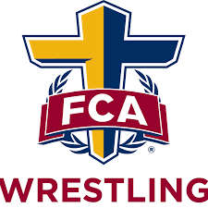

The post season is almost here, and we would like to welcome you to join us at Gainesville High School starting February 28th at 6:45pm to kick off the Spring season. During the month of March, we will primarily focus on Folkstyle for those that are going to compete in MAWA, super states and the NHSCA tournaments. Moving into April and May we will shift our focus to Freestyle and Greco to prepare for the VA State Freestyle and Greco tournament in May. Below is a QR code that will bring you to the registration
https://fca.regfox.com/2023princewilliamwrestling
Maximum 50-person registration
Season information:
Location: Gainesville High School, 13150 University Blvd., Gainesville, Virginia 20155
Day(s) and time: Tuesday and Thursday, 6:45-8:45
Start Date: February 28th, Tuesday
Cost: $225, shirt included.

Email Corey Burns at cburns@fca.org with any questions! Check out our website for further information at https://novafcawrestling.org/

